NAME : E.G.PRADEEP.

ROLL NO :RA2211004050026.

SUBJECT:UNIVERSAL HUMAN VALUES.

SUBJECT CODE: 21LEM102T.

DEPARTMENT:B.TECH.ECE -2NDYR.

ASSSIGNMENT ON :SOCIAL AWARENESS.

SOCIAL AWARENESS

As we grow,social awareness skills and societal awareness help us to understand how one fits into and contributes to the community and the world, as well as how we get what we need from the world.In the long term,social awareness skills will help us understand professionalism in the workplace ,as well as make it easier to share information,communicate,and collaborate with others.from a personal point of view,social awareness is a fundamental part of creating friendships And relatioships –helping us to lead happy

and fullfilled lives.

ONE’S GOAL TOWARDS SOCIAL AWARENESS

Nowadays, pollution has been increased everywhere. To avoid this situation we must reduce the pollutants to increase the pollution. One should plant trees and plants to avoid pollution. It causes many natural disasters including soil erosion,air pollution,reduce the fertility in soil. We should take care of the environment towards deforestation.By increasing the afforestation we can avoid pollution and ozone depletion

MY DUTIES ON SOCIAL AWARENESS

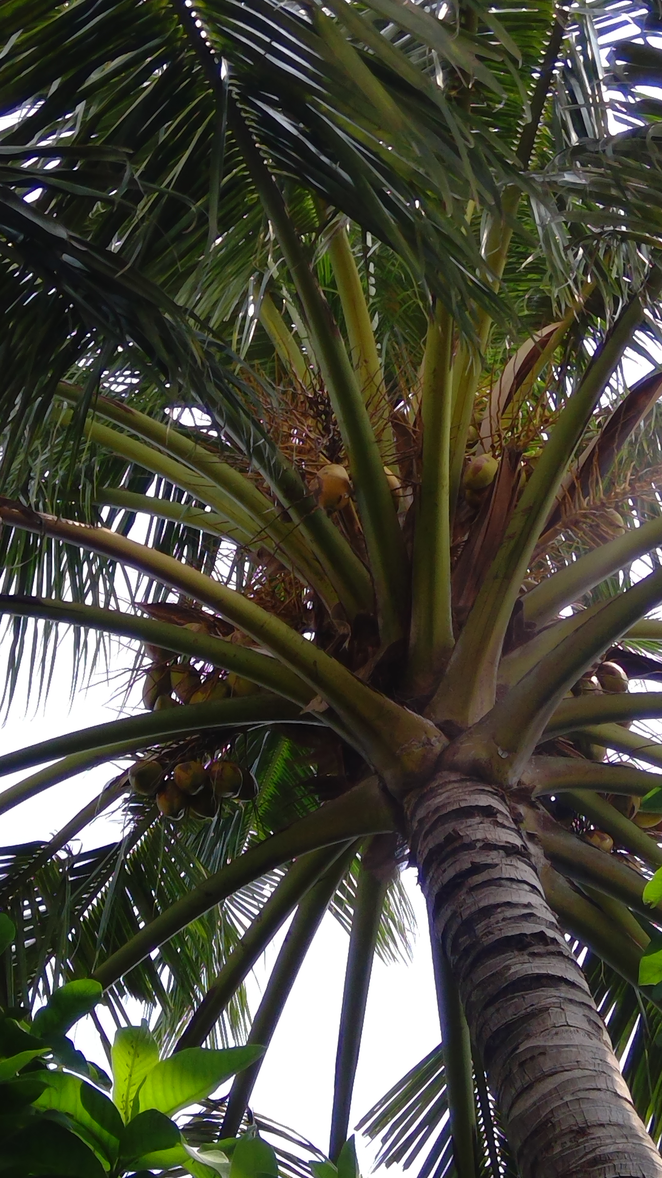

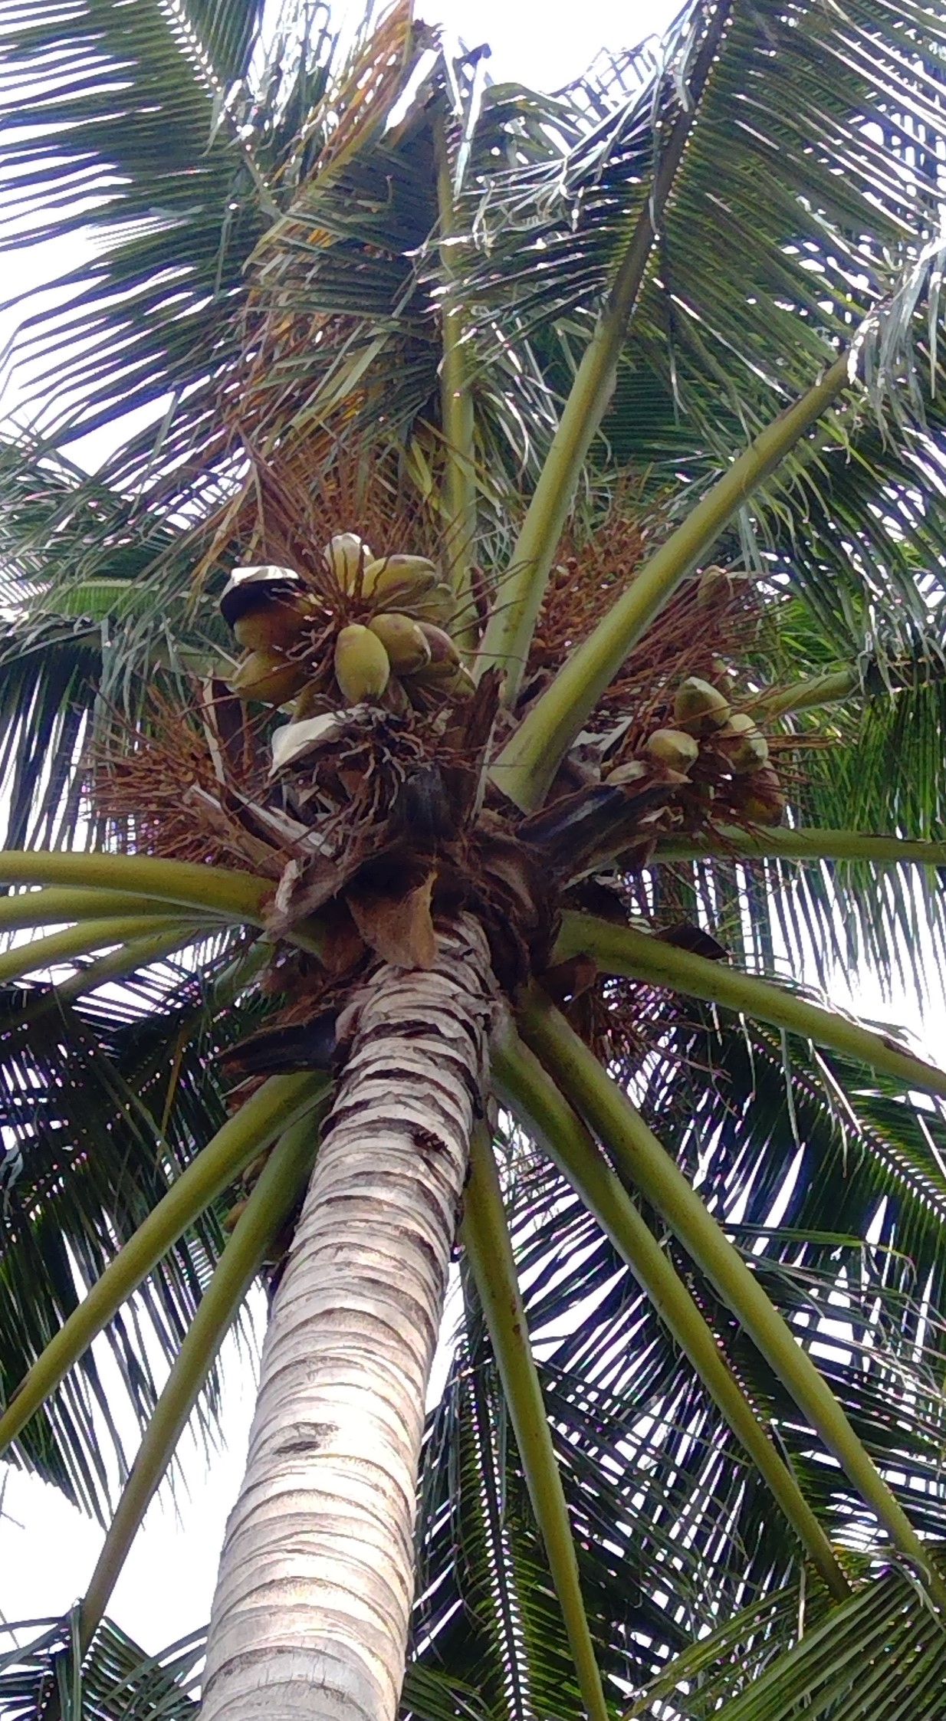

From my childhood I have grown many plants and trees.Its my hooby to grow many plants and trees. I was so interested to make a garden. In my house , I have planted many trees and plants. My father helped me to plant trees.

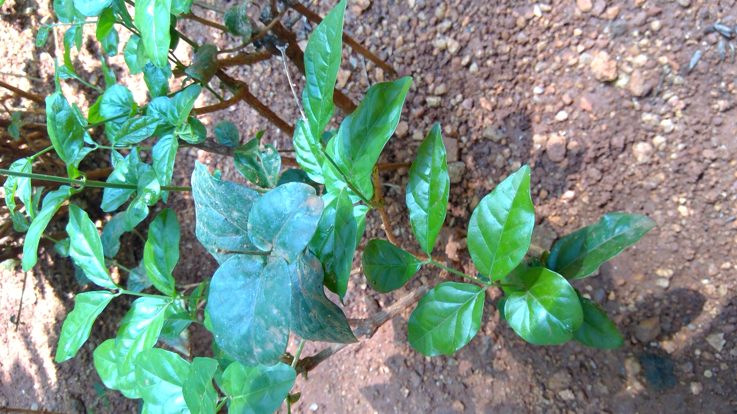

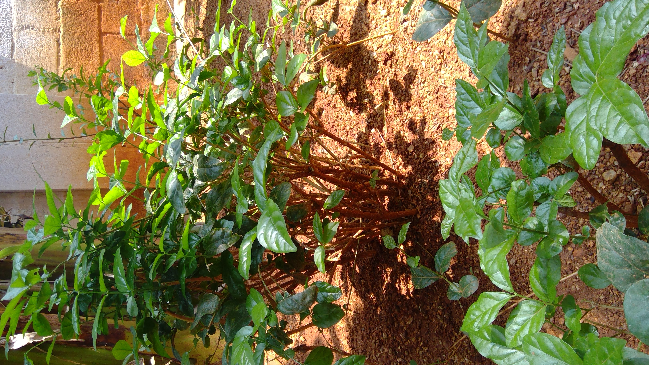

In my summer holidays, I used to plant my treesand plants. Every day evening,I poured some water to plants and trees that I planted.On weekdays, I used to pour some fertilizers and pestisides.Its my hooby to plant trees.

In my school,I was inspired by my teacher,that he planted more thanm 100 plants and he used to maintain weekly. He my inspioration to achieve my goal towards afforestation.It helps to slow down the global warming by reducing CO2 in the atmosphere and introducing more O2.Afforestation helps to protect endangered species by providing them natural habitat.It also helps to reduce the effects of drought.Trees perform a vital role in the regulation of the water cycle.Afforestation helps in the conservation of wildlife.The effects of afforestation are increased carbon sequestration.It incrases the soil stability because the roots of trees help to hold soil particles firmly together thereby reducing soil erosion.